Luke Wrap Up:
A Story Shifted

QUESTIONS FOR SMALL GROUP DISCUSSION:

- How does the book of Luke shift the whole story of the Bible? What would the story arc of the Bible look like without the gospels? What would the story look like without the Fall in Genesis?

- As a “Theophilus,” how certain do you currently feel about the work of Jesus?

- Life looks very different than a month ago. Has he upended any of your delusions? (your delusion of independence? delusion of power? delusion of health, safety, sustenance? delusion of productivity and performance? delusion of distractions?)

- How has Luke been a comfort to you? A warning? An impetus to mission or ministry? Did it change how you see the body of Christ? Did it change how you think of spiritual forces? Were there any surprises in reading it this year?

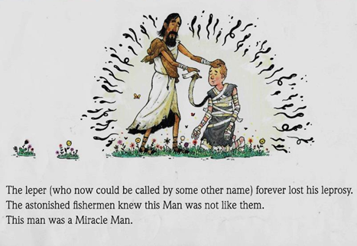

- Whole Bible Story Arc:
Resolution:
-Happily ever after

-Often a return to original setting, peaceful state, home but with enlightenment or maturity
Falling Action:
-central conflict solved/decreased

-progression toward conclusion
Exposition:
-Introduction to setting

-Primary and Secondary players

Climax:
-Heroic intervention

-Sacrifice for companion, community, country

-Major problem solved

Rising Action/ Tension:
-trials and mistakes

-deeper understanding of foe/conflict and hero

-foreshadowing

Inciting Incident:
-Problem or trouble enters

-Antagonist arrives

-Flawed choice

Genesis | Genesis | Remainder of OT | Gospels and Acts | Remainder of NT | Revelation (ish)
-Genesis and garden  -Creation  -God and people | -Serpent  -Sin  -Fall | -Covenants  -Exodus and exiles  -Law  -Priests and Sacrifices  -Tabernacle  -Kings  -Christ types | -Christ’s death and resurrection  -Ascension  -Pentecost  -New covenant   | -How to live in light of Christ  -Church waiting | -New heaven and new earth  -Eternity

OT establishes a conflict. NT resolves that conflict.

- Narrative Order: Hero’s Journey

“Viewing Luke-Acts on the large canvas of narrative analysis, it is possible to see in its entirety a simple narrative cycle, painted in broad strokes. In it we see the working out of God’s purpose to bring salvation in all of its fullness to all people.” (Green 9)

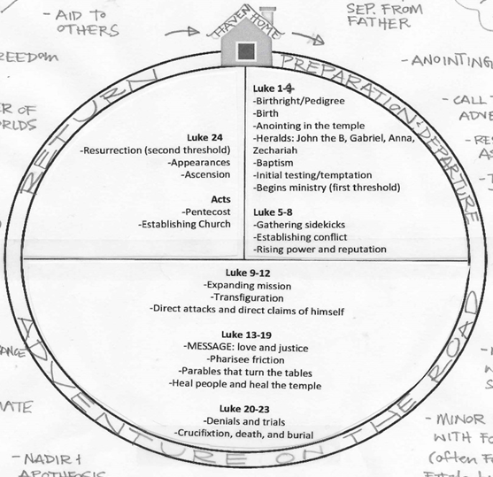
- Christ as Hero on a Quest

- What we see in the narrative cycle is a unity and consistency in our stories, in creation.
- Boon

Even if he isn’t physically present, our king’s victory has changed our battle.

- “Cosmos out of the Chaos” Madeline L’Engle

- Themes

- JUSTICE AND NEW WORLD ORDER

“He has brought down the powerful from their thrones, and lifted up the lowly” 1:52

He turns the tables so He can PREPARE THE TABLE.

There is “orientation not to ‘proper behavior’ per se but toward a reconstructed vision of God and the sort of world order that might reflect this vision of God… Jesus thus calls on people to live as he lives, in contradistinction to the agnostic, competitive form of life marked by conventional notions of honor and status typical of the larger Roman world,” (Green 23-4).

- LOVE AND HEALING

- Forgiveness of Sins
- Redefining Love: Neighbor and Enemy
- Christ gives life
- Dissolving barriers and creating kinship to an ever widening mission to all nations

“Luke depicts so many varied groups of people; “but he goes further, and shows us particular persons within those classes. .. the gospel is not only for Jews, but also for Greeks—and for Romans and for Samaritans too. It is not only for males, but also for females—and not simply important women like the wife of Herod’s steward, but widows and cripples and prostitutes as well. It is not only for freemen, but also for slaves—and indeed for all whom society despises: for the poor, the weak, and the outcast, for the thief,” (Wilcock 18)

- A Common Enemy and Easter

He came to mend torn shalom. To heal all creation. Reverse the curse. And brings the story back around even better.

Luke, the story of Christ, the whole story of the old and new testament is the attack against this enemy villain, unseen lurking shadow. Christ is the healer for this cosmic infection. The hero to conquer and destroy this villain Death.

